**Experiment 4: measurement of amplifier frequency response.**

The following plot shows how frequencies from 20-20000Hz (approximate range of human hearing) are amplified. For a perfect amplifier this would be a straight horizontal line. However, all that is required for intelligible speech is a frequency response between 400 and 4000 Hz with a tolerance of 1dB.

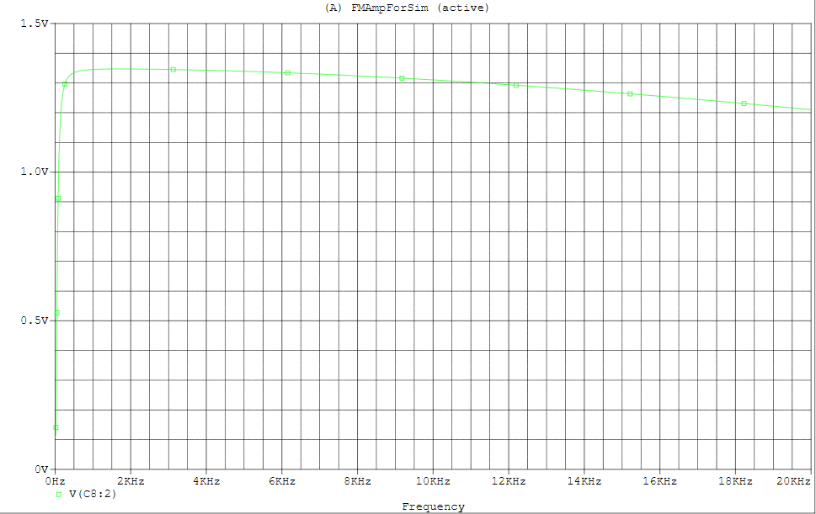

We’ve actually done quite a bit better than that, it drops off at the low end, but we get a frequency response between 180 and 20000 Hz with a tolerance of just 0.93 dB. This is more than sufficient for a basic radio application.

Below is an expanded plot of the frequencies from 1 to 300 Hz. This show how the amplification drops to nothing as the frequency drops. However, this only starts to happen below around 200 Hz which is the lowest 1% of the audible frequencies so isn’t a problem.

